PIZZA SALES SQL QUERIES

# KPI’s

## Total Revenue:

SELECT SUM(total_price) AS Total_Revenue FROM pizza_sales;

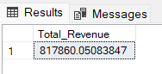

## Average Order Value

SELECT (SUM(total_price) / COUNT(DISTINCT order_id)) AS Avg_order_Value FROM pizza_sales

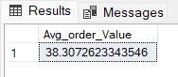

## Total Pizzas Sold

SELECT SUM(quantity) AS Total_pizza_sold FROM pizza_sales

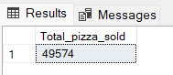

## Total Orders

SELECT COUNT(DISTINCT order_id) AS Total_Orders FROM pizza_sales

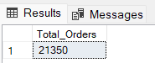

## Average Pizzas Per Order

SELECT CAST(CAST(SUM(quantity) AS DECIMAL(10,2)) /

CAST(COUNT(DISTINCT order_id) AS DECIMAL(10,2)) AS DECIMAL(10,2))

AS Avg_Pizzas_per_order FROM pizza_sales

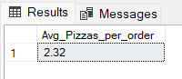

# Daily Trend for Total Orders

SELECT DATENAME(DW, order_date) AS order_day, COUNT(DISTINCT order_id) AS total_orders

FROM pizza_sales

GROUP BY DATENAME(DW, order_date)

***Output:***

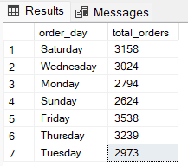

# Monthly Trend for Orders

select DATENAME(MONTH, order_date) as Month_Name, COUNT(DISTINCT order_id) as Total_Orders

from pizza_sales

GROUP BY DATENAME(MONTH, order_date)***Output***

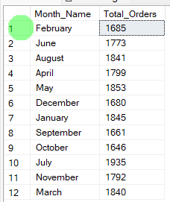

# % of Sales by Pizza Category

SELECT pizza_category, CAST(SUM(total_price) AS DECIMAL(10,2)) as total_revenue,

CAST(SUM(total_price) * 100 / (SELECT SUM(total_price) from pizza_sales) AS DECIMAL(10,2)) AS PCT

FROM pizza_sales

GROUP BY pizza_category

***Output***

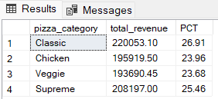

# % of Sales by Pizza Size

SELECT pizza_size, CAST(SUM(total_price) AS DECIMAL(10,2)) as total_revenue,

CAST(SUM(total_price) * 100 / (SELECT SUM(total_price) from pizza_sales) AS DECIMAL(10,2)) AS PCT

FROM pizza_sales GROUP BY pizza_size ORDER BY pizza_size

***Output***

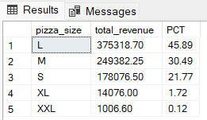

# Total Pizzas Sold by Pizza Category

SELECT pizza_category, SUM(quantity) as Total_Quantity_Sold FROM pizza_sales

WHERE MONTH(order_date) = 2 GROUP BY pizza_category

ORDER BY Total_Quantity_Sold DESC

***Output***

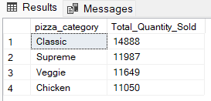

# Top 5 Pizzas by Revenue

SELECT Top 5 pizza_name, SUM(total_price) AS Total_Revenue FROM pizza_sales

GROUP BY pizza_name

ORDER BY Total_Revenue DESC

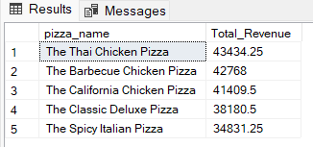

# Bottom 5 Pizzas by Revenue

SELECT Top 5 pizza_name, SUM(total_price) AS Total_Revenue FROM pizza_sales

GROUP BY pizza_name

ORDER BY Total_Revenue ASC

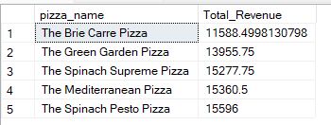

# Top 5 Pizzas by Quantity

SELECT Top 5 pizza_name, SUM(quantity) AS Total_Pizza_Sold FROM pizza_sales

GROUP BY pizza_name

ORDER BY Total_Pizza_Sold DESC

***Output***

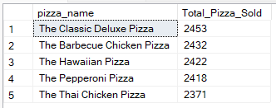

# Bottom 5 Pizzas by Quantity

SELECT TOP 5 pizza_name, SUM(quantity) AS Total_Pizza_Sold

FROM pizza_sales GROUP BY pizza_name

ORDER BY Total_Pizza_Sold ASC

***Output***

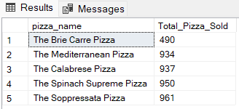

# Top 5 Pizzas by Total Orders

SELECT Top 5 pizza_name, COUNT(DISTINCT order_id) AS Total_Orders FROM pizza_sales

GROUP BY pizza_name

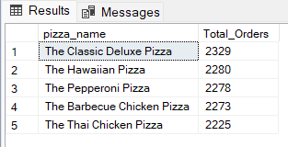ORDER BY Total_Orders DESC

# Borrom 5 Pizzas by Total Orders

SELECT Top 5 pizza_name, COUNT(DISTINCT order_id) AS Total_Orders FROM pizza_sales

GROUP BY pizza_name

ORDER BY Total_Orders ASC

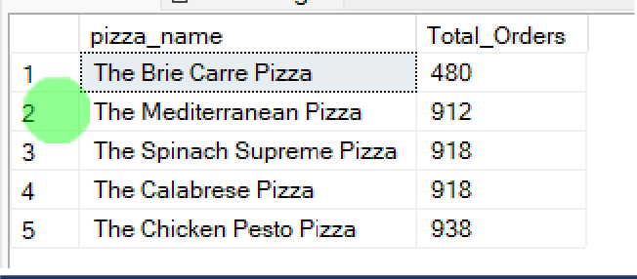

***NOTE***

If you want to apply the pizza_category or pizza_size filters to the above queries you can use WHERE clause. Follow some of below examples

SELECT Top 5 pizza_name, COUNT(DISTINCT order_id) AS Total_Orders FROM pizza_sales

WHERE pizza_category = 'Classic' GROUP BY pizza_name

ORDER BY Total_Orders ASC